**Vanessa Nakate – Young Climate Activist, UK**

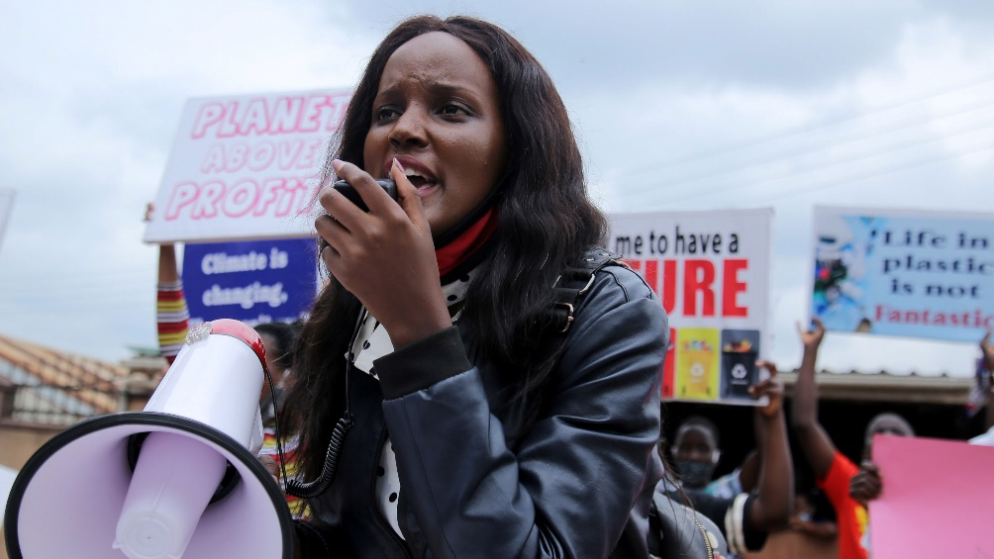Vanessa started her journey as a climate activist in 2018. The climate crisis has been one of the greatest threats affecting the lives of many Ugandans - and she became increasingly aware and concerned about communities particularly vulnerable to the crippling impacts of a warming planet.

“If you travelled two to three hours away from Kampala to a certain rural community, you'll understand how people would struggle to find water and how people's crops are drying up because of the extreme dry conditions” says Vanessa who joined the Fridays for Future movement in Uganda and founded the Rise Up initiative to amplify the voices of activists across Africa.

“Climate change is more than statistics… It’s about the people, it’s about the people who are being impacted right now.”

Vanessa is one of the millions of determined activists who are demanding that politicians and those with influence do more to acknowledge and act upon the reality and severity of climate change, placing human rights and justice at the heart of all efforts. She also believes that there needs to be a separate fund to help people recover the loss and damage they suffer from the consequences of the crisis.

“These are some of the injustices of the climate crisis - those who didn't cause the climate crisis, those who aren't responsible for the rising global emissions - they're the ones on the frontlines. They're the ones whose voices are not being listened to. And they're the ones who don't get climate finance for mitigation, or adaptation, or finance for loss and damage.”

**“In the end, you know, we cannot eat coal, we cannot drink oil.**And, again, something else that one of my friends says… that money will be useless on a dead planet.”